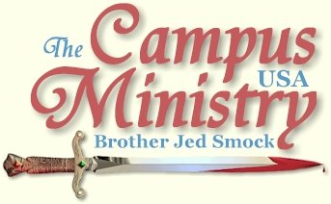
brojed@aol.com
brojed.org
573-999-0347
573-999-0347
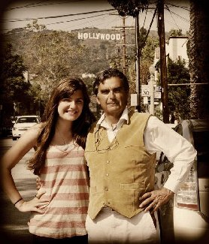

Dear Saints,
Starting Monday, March 21 a team of us, Bro Jed, Martha, Sis. Cindy, Priscilla, Sis. Pat and Dave and Doris Metz will be preaching on campuses in Texas and Oklahoma for two weeks. Please pray for our daily ministry. Also if you would like to give a special offering to finance the added expenses of this trip, see the info at the end of this e-journal. Thank you fellow laborers!
THE FILM MAKERS

San Diego State, March 7, 2011

It rained off and on all morning. Corey, Chad and Brooke interviewed Dennis and me in his beautiful mountain top home in the morning. These graduates are making a film on my life and ministry. Chad made a short documentary on me to complete the requirements for his degree last year. Now he wants to do something more complete. The film crew will be with me for the rest of the week. A number of people have made documentaries on me over the years. To my knowledge none of them have been widely circulated. I am convinced there is good material in my daily ministry to make a movie that would have wide interest to a crossover audience as evidence by the crowds and interest we draw day after day, week after week, month after month, year after year and decade after decade.

The film crew

The weather predictions were that the sun would come out by 3 PM. So we arrived on campus in time to preach the 2 PM break. Neil was holding up his banner. Makala also met us on campus.
The windy, wet and cold weather was not breaking. The temperature never reached the 60’s. The sun never did come out. I did not get a crowd at either the 2 or 3 PM break. The weather was just too uncomfortable for Southern Californians. A few made derogatory comments in passing. One girl said, “College students do not want to be preached to.” She admitted that she liked to get drunk. I replied, “I am not here to give people what they like or want. They need to be rebuked for their sinful ways.”
Neil manages to get in a conversation with a few Muslims. We left at 3 PM in a light rain. The weather looks better for the rest of the week.

DISGRACEFUL PRACTICES OF THE HEATHEN

San Marcos State, March 8, 2011

A booth was set up in the free speech area offering a “Spiritual Reading.” Bibles were available but they were mostly passing out lollipops with Bible verses on the wrapper. The booth was sponsored by Chi Alpha, which is the college outreach of the Assemblies of God.
I taught that a spiritual reading of the Bible tells that unbelievers are lost and condemned to Hell, unless they repent and believe the gospel. Two boys were sitting on the wall, both of whom were unbelievers. I rebuked them for their unbelief.
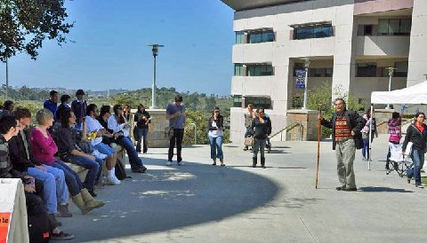
"Spiritual Readings" offered in booth to the right.

A woman in the booth chastised me for preaching condemnation. “You need to preach God’s love,” she said to me.
“People have to know they are condemned before they will seek a Savior,” I responded.
She reiterated the need for me to speak on love. I asked, “What is love?”
She answered, “God is love.”
“But love is not God,” I responded.
She claimed that love is God.
“Love is her God,” said a catholic boy carrying a Bible with whom I started conversing.
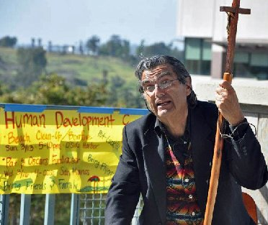
"...but love is not God,"
I stopped preaching since the Student Government was rallying for candidates for student offices to give campaign speeches. After their uninspiring speeches, I raised my voice again. For about 45 minutes I had a crowd of around 25. At 1 PM most of them went to class and the Spiritual Reading tent folded up. I continued and until 4 PM I had an attentive group of six to 12 listening.
I dialogued with Stephanie who was in the audience most of the afternoon. Early in the day she said she saw nothing wrong with lesbianism. About 3 PM she was still sitting on the wall and I was having a relatively high level of conversation with several students including the two boys that had stopped first.
Suddenly, Stephanie asked, “What is wrong if a man goes down on his wife?” [I am a little embarrassed to write this question in my journal. But she did not seem to be the least embarrassed to ask the question.]
My response was, “That is degrading to the human body. Dogs may sniff around down there but it is not appropriate for human beings.”
Oral sex is sodomy whether practiced in marriage our outside of marriage. Stephanie could not see anything wrong with it. I suggested that if she would become born of the spirit she would comprehend these things. I urged her to ask more edifying questions concerning the purpose and meaning of life and not be so preoccupied with orgasms. She did do better and asked more searching questions. Before I closed the meeting she did admit that she went to church sometimes with her sister who is a Christian. I said, “Since your sister must be praying for you I have a lot of hope that you will be saved.”
“For it is a shame even to speak of those things which are done of them in secret.”—Eph 5:12. Preacher Neil, who held a banner while I was speaking on other S.D. campuses, rebuked me with this scripture in an email sent out to a list of preachers the other day. His argument was that I know that I am disobeying the Bible in speaking of the filthy things sinners do in privacy.
It is a disgrace that I have to address subjects like oral and anal sex, especially in an academic setting. But that does not mean that I should not speak of these things at all. We live in a generation in which women have been taught they should be preoccupied with orgasms. I get no perverse delight in addressing these issues but I am well aware that American minds, especially college students, are preoccupied with sex. It is necessary to address these issues. If I do not bring it up, they will. The Spiritual perspective needs to be known on questionable and perverted sexual practices.
The previous verse from Ephesians 5 says, “And have no fellowship with the unfruitful works of darkness, but rather reprove them.” We need to reprove students’ perverse practices and warn them that according to Eph 5:5, “No whoremonger, nor unclean person, nor covetous man, who is an idolater, hath any inheritance in the kingdom of Christ and of God.”
I explained to Stephanie that “going down” fell under the category of uncleanness, that she should not allow herself to be degraded by the lust of the flesh. Someone has to say these things for they will rarely be said in church. And they certainly will not be said from a Christian booth which is passing out suckers to lost and undone children.
I notice that Stephanie has become my friend on facebook.
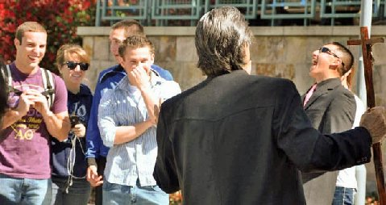
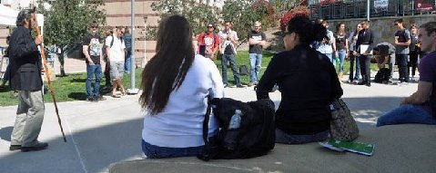
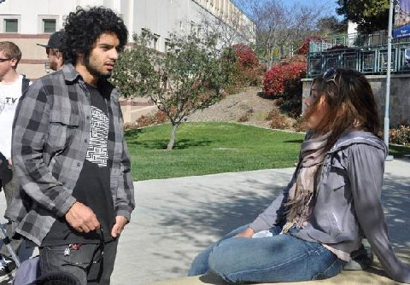
Mikaela (right) Witnesses Boldly on the Sidelines

PREACHING REPENTANCE ON ASH WEDNESDAY

San Marcos State and San Diego State, March 9, 2011
There was so little movement at 11:50, I wondered if it was even a class break. I went ahead and preached. A boy and a girl sat down to listen. The girl said that she had been converted on February 22. The boy was not a believer but he was respectful. They told me that there were not many classes on Wednesday afternoon. I preached against sin. I reminded the students that this is Ash Wednesday, which is supposed to be a day of repentance as the Christian world prepares for the Lenten season, which is to be 40 days of prayer and fasting. Several students passed with ashes on their forehead. I asked them if they had forsaken all sin. I received no comment.
My audience of two left as I continued preaching beyond the break. I did notice that several were listening from a distance. After about 30 minutes, I decided to take a break. The film crew had taken Martha to another location to do an extensive interview with her for the movie they are making. About 12:40 I started preaching again, there were more passing at the 12:50 break than the previous exchange of classes but traffic was still relatively sparse. This time no one stopped, except for more than a few minutes. I concluded that this was not a good day to preach at San Marcos State.
I determined to drive to San Diego State hoping to get there in time to preach at the 1:50 break. I arrived on the steps of the Aztec Union at 1:55. I preached for 15 minutes with my sandwich board. But no one stopped. I noticed that three women were manning the Islamic outreach table. One was wearing a full back burque with only a slit for her eyes. That is rare to see on a college campus. No Christians had a literature table. I tried preaching again at 2:50; there was a fairly steady flow of traffic until 3:30. I preached; but once again I only had several stop for a few minutes and make a few comments or ask questions than they moved on. I said to Mikaela and Martha Marie, “Well, I have given it my best shot on two campuses. I am ready to call it a day.”
It was a disappointing day especially since the weather was ideal, sunny and in the low 70’s. I did confront hundreds with their sin and warned them of the consequences of sin. What more can I do?
Many girls seemed to think that it was a good day to flaunt more flesh than they covered. Some of their outfits were almost unbelievably immodest. I suppose I was one of the few who gave their impropriety any thought.

THE SHOW MUST GO ON!

San Diego State, March 10, 2011

After striking out yesterday, I decided we needed more visual aids. I got the banner out for the first time this year and three sandwich board signs. I preached with the staff in one hand and wearing my sandwich board listing sins. Martha held the banner and wore another sign warning about Hell and we had another sign ready for Mikaela when she arrived.
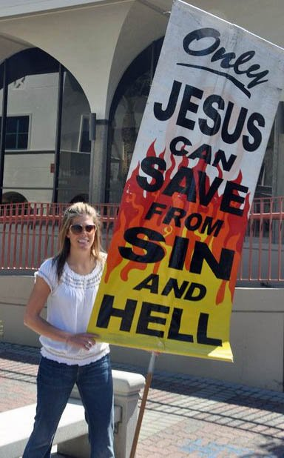
Mikaela helps with the visual aids.
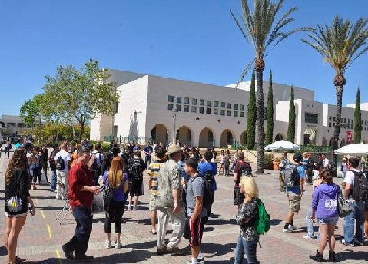
Crowd Gathers; Can you find Bro. Jed?
It did not take long for me to get the attention of Katie, who was a pretty girl (not so pretty on the inside) wearing a dress. She soon identified herself as bisexual, claiming that nothing was wrong with that perverted behavior. Katie was a live wire and I was able to use my 20 minute dialogue with her to draw a crowd of about 50. She kept referring to my “fictitious book” and my “fictitious God.” I was surprised that no one interrupted our dialogue. Finally, she had to go to class. I spoke of the girls at San Diego State not having a good reputation. I said that I have more respect for the professional prostitutes than the college girls who just give it away.
Lo and behold who should interrupted me but a banner toting preacher wearing a Jesus shirt name Neil Konitshek: “Jed, what you are saying is inappropriate. Don’t say that. You are putting on a show. I am going to continue to oppose you as long as you are saying these inappropriate things.” I simply ignored his feeble attempts to shut me down and let the show go on.
I am beginning to wonder if Paul’s thorn in the flesh was not persons like Neil. There was another thorn in Arizona who interrupted my preaching claiming I was merely a showman; he prophesied I was coming down. I have been encountering guys like Neil and Monte who have come against my ministry since I started. Most of them disappeared from the scene years ago. Others have tried to cast demons out of me. I usually simply laugh at them. They know nothing of ministerial ethics. I am not going down; I am headed up.
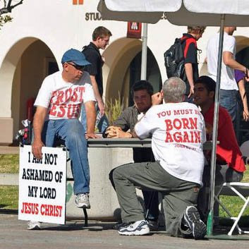
Preacher Neil: Bro. Jed's Thorn in the Flesh!
Another Christian group was on campus wearing t-shirts which read “Body piercing saved my life.” One of them ended up reproving me saying, “You are preaching hate.”
There was another organization carrying banners which read, “Zeitgeist Movement of S.D.,” They advocate no money and no property, utterly foolish and evil ideas. Despite all the interruptions and opposition of various groups, as always, I prevailed.
By 2 PM I taught a quiet group of students who were sitting on the steps. Some of whom were Christians who were listening quietly. From 3 to 4 PM I answered questions from atheists. They were well-behaved and one even brought me a cup of cold water.
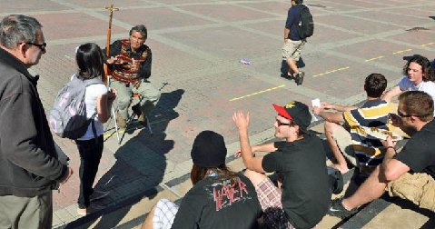
"By 2 PM I taught a quiet group of students who were sitting on the steps."
If atheists are right it signifies nothing. If Christians are right, it means everything.
Mikaela thanked me profusely as we left campus for calling upon her. She was obviously high in the spirit after giving her witness. She is a graduate of Patrick Henry College and has been used to being around believers all her life. She enjoyed standing for truth in the midst of all the lies.

Mikaela enjoyed the opportunity to stand for the truth.

One other thing, Neil told me to preach holiness. When I said Christians don't sin. He opposed that. When I said I obey God, he objected to that. How can we preach holiness and excuse sin?

JED, JR.
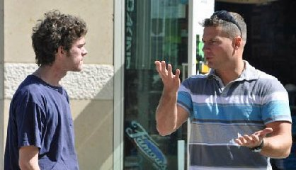

UCSD, March 11, 2011

My San Diego thorn in the flesh, Neil, posted the following on my facebook concerning yesterday’s preaching, “I quietly listened until you ‘brought out your bag of tricks’ as you must do because you have no anointing from God. You use foul language to insult people so they will yell and your crowd will grow. You are nothing but a cheap side-showman. Your behavior is despicable and you have been warned enough times by many different preachers.
If you come out to UCSD tomorrow I will stand against you again and every time you come from now on. No more of this behavior. I don't care if you have been preaching for 138 years, what you are doing is improper and DEMONIC. It is time people stand up against this ‘Old Boys Network’ and speak the Truth.”
Words like these from Neil are like saying Amen to another preacher. I was ready for a showdown when Martha and I arrived on campus. My thorn arrived shortly after us. Before I started preaching he indicated that he wanted to talk with me. But it was almost immediately evident that he was reiterating his threats to oppose me and justify his unethical behavior, which stirred me to start preaching even before the class break. The thorn began railing against me claiming my ministry was going to come crashing down. And that I was not going to get a crowd today. I am experienced enough to know that the Lord would use his railings to quickly draw a crowd. So the thorn was making it easy for me to do what he prophesied I would not be able to do.
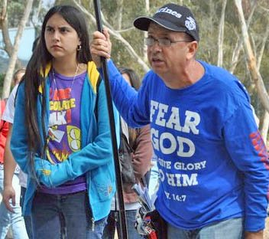
Neil, The Thorn!
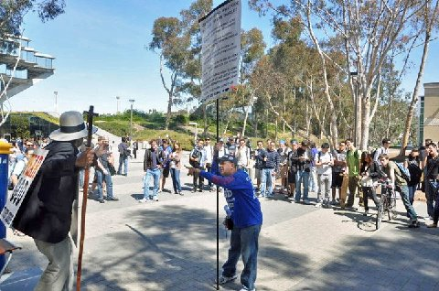
"So the thorn was making it easy for me to do what he prophesied I would not be able to do!"
The thorn was like a broken record today; he must have asked me fifty times, “When is the last time you sinned?” Mostly, I ignored his questioning. He hates the doctrine of what Wesley called Christian perfection. I did say on several occasions that I do not remember the last time I sinned, based upon the following from the Bible, “God has promised to remove our sins as far as the east is from the west and he will remember them no more.”—Ps. 103, Heb 8&10. I also answered, “If I told you the last time I sinned you would not believe me. Or if I said I sinned within the last year, you would say, ‘Physician heal thyself.’ So this is all the answer you will get from me.” These answers did not satisfy him so he railed on. He was so beside himself I do not know if he even heard these answers.
My hosts, Dennis and Victoria came on the scene for an hour. They quietly listened for a while. Then Dennis talked to Neil and with his gentle spirit had the effect of calming Neil temporarily. Afterwards, Dennis directed his voice to the crowd and gave them a short gospel message. The students appeared to be attentive as he spoke. When Dennis and Victoria had to leave, the thorn climbed back on his high horse.

"Dennis (my host) directed his voice to the crowd and gave them a short gospel message."
Martha finally interrupted Neil. “Stop asking the question. My dad has already answered it several times. You are not going to get the answer you want. I have never seen my dad sin. He has never even yelled at me.”
Shortly thereafter, Chad, Mikaela’s husband, intervened and tried to reason with the thorn, but he is not much for logic. Soon the thorn started asking Chad, “When was the last time you sinned?” Neil was momentarily taken aback when Chad replied, “About three years ago.” They ended up having about a 30 minute argument; I was glad to have the break. Chad questioned Neil who confessed that he only sinned occasionally. I was quite impressed with Chad. Even though I had met him for the first time on Sunday, I was flattered when Neil referred to him as “Jed, Jr.”
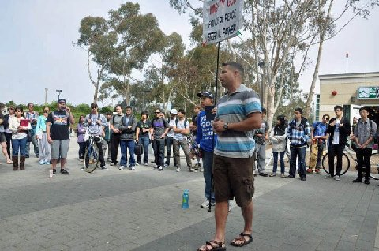
Chad Takes a Stand for Holiness

Mikaela stood with us all week and was a great help in the ministry.
There were times when Neil was not firing his powerless blanks at me. During these intervals I was able to teach out of 1 John and put 1 John 1:8 in its context. I do not have a great problem with people like Neil who claim to only sin occasionally (depending on the nature of that sin). But I do have a major problem when they teach that we cannot help but sin at least occasionally.
I confess that a few times today I used terminology or some of my memorable one-liners in order to press Neil’s buttons. He even objects to specifically referring to masturbation. He opposes use of derogatory words concerning homosexuals. He even asked me, “How many times did Jesus mention homosexuality?” I am sure we have all heard that one before. Obviously, the thorn has a lot of buttons that are easy to press.
Cindy wrote the following today on facebook as an answer to Neil’s complaint about my foul mouthed preaching:
Neil, you would have rebuked Isaiah for preaching naked and Ezekiel for telling the wicked that they would hate their sins like a woman hates her menstrual cloth...also Jeremiah for comparing Judah's sin to animals in heat...the Bible is a very crude book and God is froward to the froward! You would have joined Michal and complained when King David danced wildly in front of all Israel with very little on. May God forgive you for your youthful ignorance...and may the judgment of Michal NOT come upon you for standing against the man of God.
I might add that Neil would censor the Song of Solomon.
I am happy to have a wife and daughter defend my character and ministry. One common quote one often hears from preachers who oppose the Wesleyan doctrine of perfection, “If a man claims to be holy just ask his wife.” I passed the test of not just my wife but my daughter today. And not having any boys, I am happy to have a “Jed, Jr.” to affirm my teaching. I am blessed to hear about anyone living above sin. Why would anyone who claims to love the Lord, object to hearing of a brother who has the victory over sin? One major problem Neil has is that he does not understand the nature of sin. May the Lord raise up many more like Chad!
One old trick that Neil used was to try to set other preachers against me, quoting names of young preachers who he claimed opposed my “foul” tongue and had rebuked me. The only one he mentioned who I remember trying to correct me was poor Monte. Neil even tried to bring division between my host and me.

Thank you for your faithful prayers and support. Please continue to pray for us. You may donate to CMUSA using PayPal by going to our web site brojed.org or by mailing your check to our home address: CMUSA 2402 Longview Dr. Columbia, MO 65203. All gifts are tax deductible. Thank you for your generosity.

